Setting up API and TSV2

Step By Step Guide

**Revision History**

|  |  |  |  |
| --- | --- | --- | --- |
| **Version** | **Date** | **Author** | **Comments** |
| 1.0 | 17 Feb 2014 | Bhushan Mulmule |  |
| 2.0 | 30 Mar 2017 | Ruena Vas |  |

**Authorisation**

|  |  |  |
| --- | --- | --- |
| **Position** | **Date** | **Signature** |
|  |  |  |

# Introduction:

This document is step by step guide to setup

1. TSV2 API and
2. TSV2 Website for development.

# Prerequisites

1. Travel Studio installed and working along with same version Travel Studio Database.
2. Tortoise SVN installed.
3. URL of TS API.
4. Visual Studio
5. IIS

# Installing and Registering ASP.NET and WCF for IIS

(**Note:** Incase your system is newly setup, do the following step’s)

1. Start command prompt by typing **cmd** at the Run command and then execute the command prompt with Administrator rights by right clicking and choosing Run as administrator from the context menu.
2. In the command prompt, change the directory as follows

cd C:\Windows\Microsoft.NET\Framework64\v4.0.30319\

1. Then type the following command

aspnet_regiis -iru

1. After it finishes installing ASP.NET for IIS, restart IIS with the following command.

iisreset

# Getting Source code:

We are using trunk source code for demonstration purpose. You can checkout branch as per requirement. Use following URL’s to checkout code from repository.

**API-trunk:** <http://odl-bld-srv.odlindia.com:81/svn/APIRepo/trunk>

**TSV2-trunk:** <http://odl-bld-srv.odlindia.com:81/svn/TSV2Repo/trunk>

# SETTING UP TSV2 API

**(Note: If you have already setup B2CB2B API Step 1 to 3 can be skipped)**

1. **Checkout API Repo**
   1. Create “*Working Directories*” folder in D drive if it does not exist. Inside this create a new folder, give it a name as “*DotNetAPI 26.08*” where the numbers indicate TS version in the URL of the TS API.

Right click on this folder and select “*SVN Checkout...*” option. A *Checkout* dialogue box will open asking for the *URL of repository* from which the files are to be checked out. Enter the URL here.

Do not edit *Checkout directory,* it will contain the directory path of the folder on which you had right clicked. Once URL entered click on *OK*.

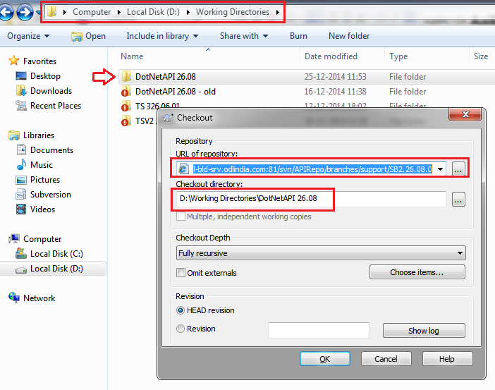

* 1. An *Authentication* dialogue box will open asking for Username and Password.
* Enter your windows login credentials. And click on *OK*.
* This will start Checkout process i.e. downloading files.

Once download is complete you will see the *Completed* message. Then Click on *OK.*

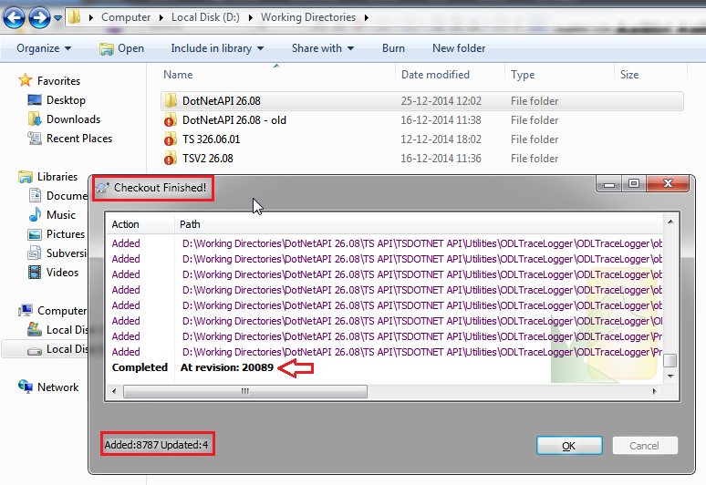

1. **Database Upsizing**
   1. Go to D: drive → Working Directories → DotNetAPI 26.08 → TSDOTNET API → B2C XML API WebService → SqlScripts and locate the file SQLSetup.exe.
   2. On double clicking the file following dialog box will open

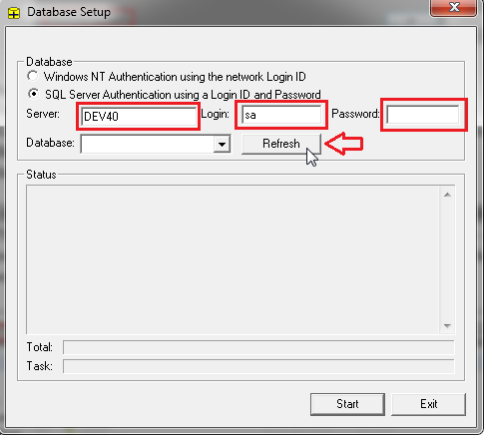

* 1. Select ***SQL Server Authentication using a Login ID and Password*** option. Enter Server, Login and Password details and click ***Refresh*** button. This will load the database list.

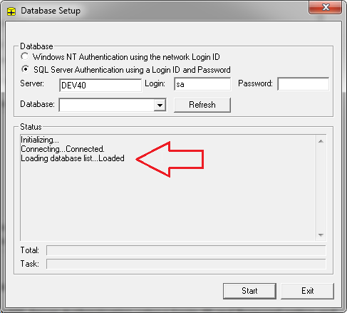

* 1. Now click on the dropdown button next to *Database:* and select the database to be upsized from the dropdown list. Then click on *Start* to start the upsizing process.

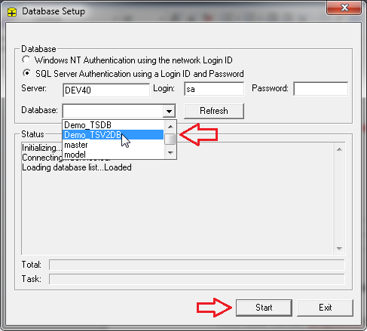

* 1. If you get any error before the *Total: progress bar reaches 100%;* Note down the script which caused error.

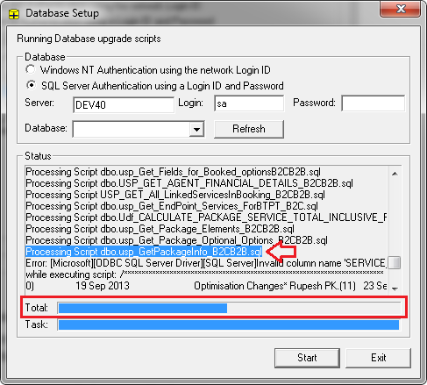

As we can see in the above image the upsizing process did not complete as shown by *Total: progress bar*. The error was caused while processing Script dbo.usp_GetPackageInfo_B2CB2B.sql (highlighted and shown by red arrow)

* 1. Comment this script from the file *scriptfiles.txt* located in the same folder i.e. D:\Working Directories\DotNetAPI 26.08\TSDOTNET API\B2C XML API WebService\SqlScripts\. To comment this script, add **!** before the script name in the *scriptfiles.txt*.

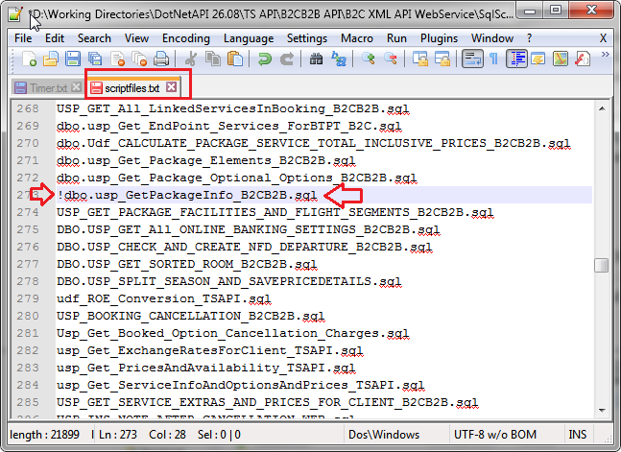

* 1. Once this is done save the file and repeat the upsizing process steps. Repeat until *Total: progressbar* reaches 100% and “*Database upsizing completed*” message is shown.

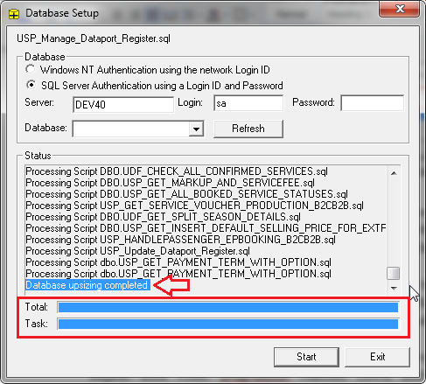

1. **Install TS Interop dll in GAC:**

Drag and drop the dll’s to ***C:\Windows\assembly*** folder. Or use **gacutil** command.

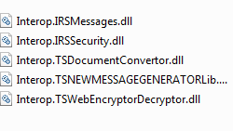

**Note**: If Drag and drop option fails on your system… install the above assemblies using the ***gacutil*** tool of .NET Framework. For details refer the below link…

<https://docs.microsoft.com/en-us/dotnet/framework/app-domains/how-to-install-an-assembly-into-the-gac> .

1. **Setup the *TSDOTNET API*****Solution**
   1. Once this is done, Open Visual Studio application as Administrator.

*(Right Click on Visual Studio → Run as Administrator)*

* 1. In Visual Studio, Choose Open Project from D drive → Working Directories → DotNetAPI 26.08 → TSDOTNET API and locate ***TSDOTNET API.sln*** which is a Microsoft Visual Studio Solution File.

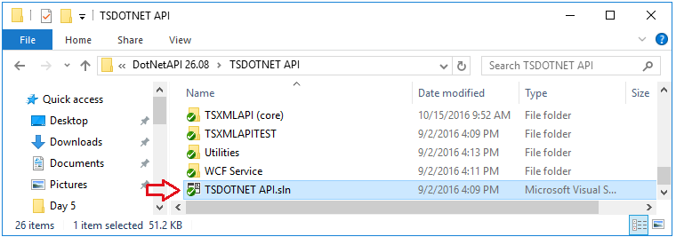

Once loading done it will open up following screen.

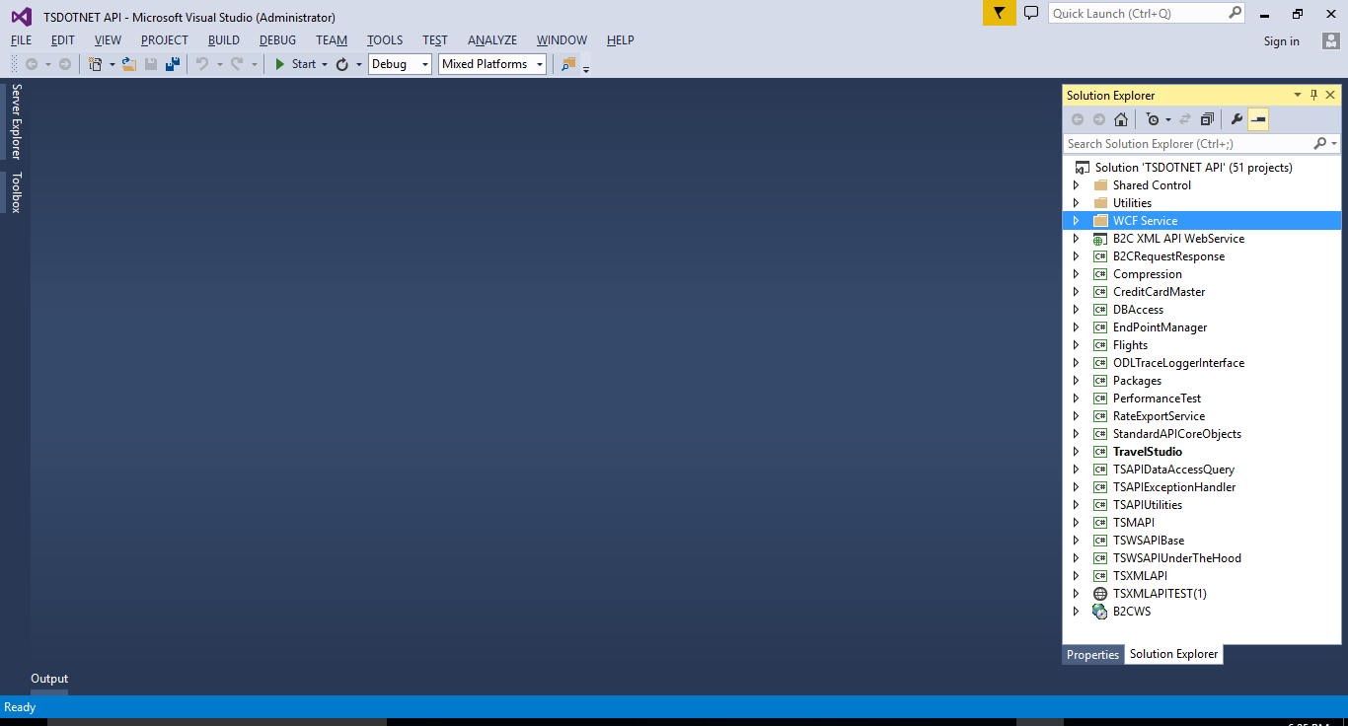

* 1. Set “B2C XML API WebService” as startup project by right clicking on the project in the solution explorer bar and selecting the option “*Set as Startup Project”*

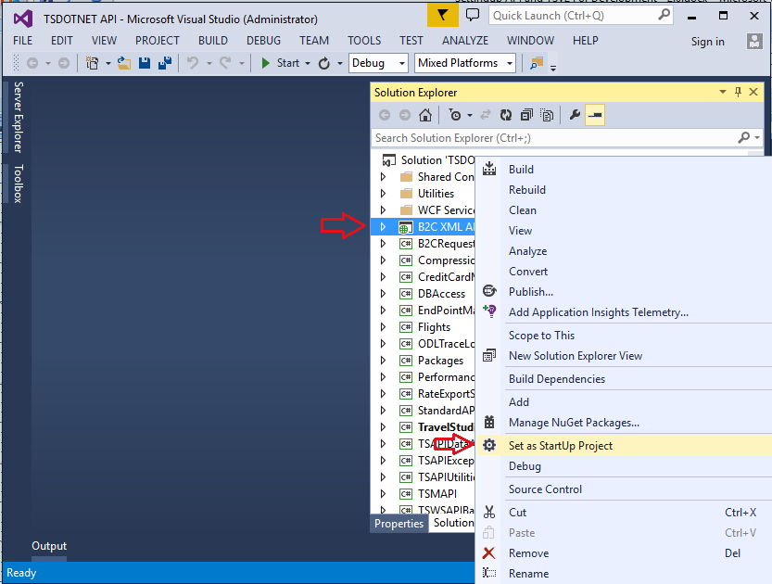

* 1. Compile the solution.

1. **Create Virtual Directory in IIS.**
   1. Right click on B2C XML API WebService project → ***Properties***.
   2. On the ***Web*** tab → ***Servers*** section → select ***Local IIS*** → click ***Create Virtual Directory.***

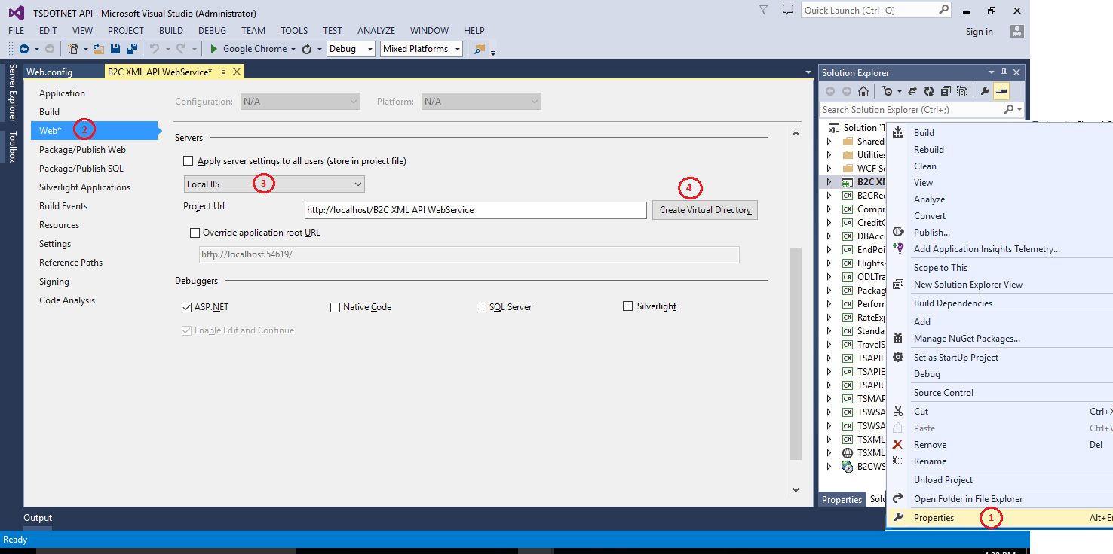

**Note:** if required you may change the name of the virtual directory.

1. **Modifying the web.config File**

Open the web.config file of *“B2C XML API WebService”* project and modify the connection string to match the database which was upsized in step 2.

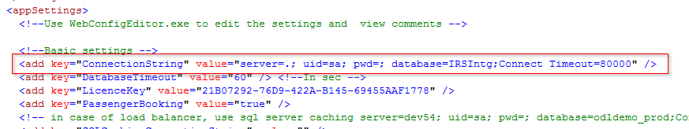

1. **Check If you able to browse API from IIS. Check the following files**
   1. B2CXMLAPIWebService.asmx
   2. Booking.svc

# Setting up TSV2

1. **Setup the TSXMLAPI Giant Solution**
   * + - 1. Open Visual Studio application as Administrator.

*(Right Click on Visual Studio → Run as Administrator)*

* + - * 1. In Visual Studio, Choose Open Project from D drive → Working Directories → TSV2Repo 26.08 → TravelStudioDotNet_PROD and locate ***TravelStudioDotNet_PROD.sln*** .

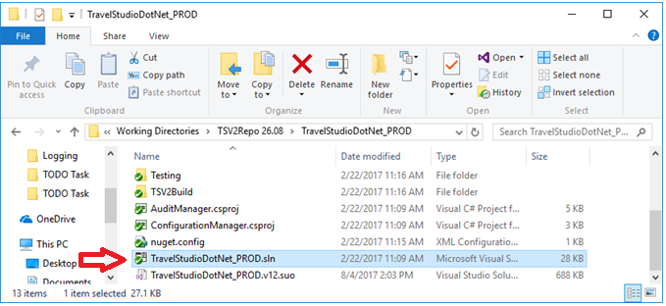

Once loading done it will open up following screen.

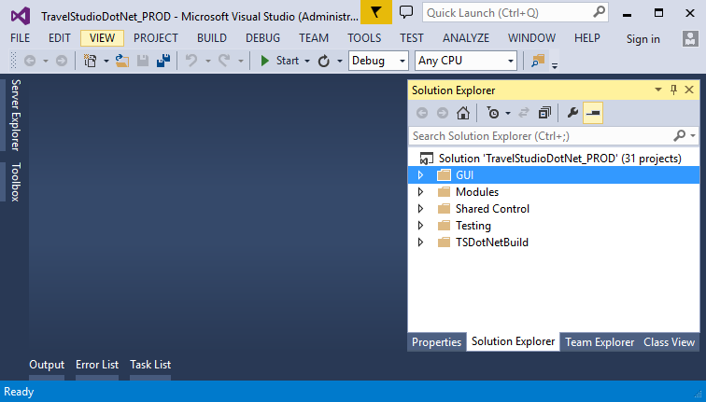

* 1. Expand GUI 🡪 ASP.NET 🡪TSBrowser🡪 Open Web.config file and specify API path as follow:

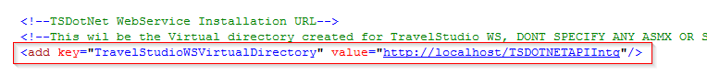

* 1. Complie **TravelStudioDotNet_Prod** solution.

1. **Create Virtual Directory in IIS.**
   * 1. Go to Internet Information Services under Control Panel 🡪Administrative tools
     2. Expand [Server Name] -> Sites -> Default Web Site
     3. Right Click on Default Web Site and Add New Application

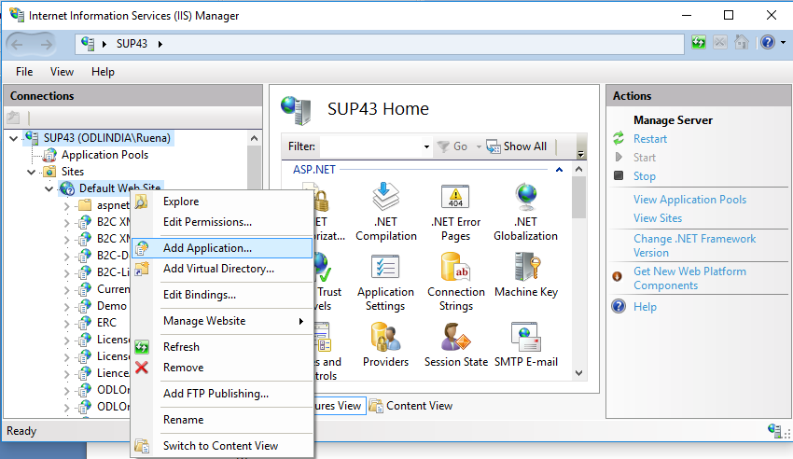

* + 1. In the Add Application Dialog window add the following details.
       1. **Alias**: Name for the Website
       2. **Application Pool**: Change the pool if required
       3. **Physical Path**: Give the full path to ***TSBrowser*** Website.

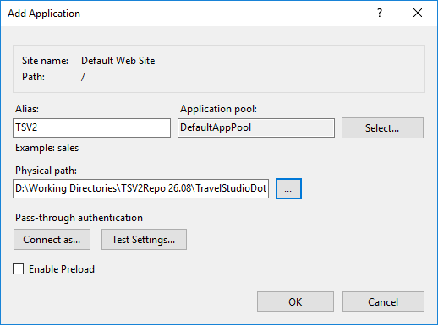

1. **Check If you able to browse TSV2 from IIS.**
   1. Browse to the Login.aspx page. You should be able to see the login page as below.

